**AUGMENTED REALITY IN RESTAURANT MENUS AND FOOD APPLICATION**

**A Project Report**

Submitted in partial fulfilment of the  
requirements for the award of the Degree of

**BACHELOR OF SCIENCE (INFORMATION TECHNOLOGY)**

**By**

**KARAN SEVALAL GOSAI**

Seat Number: _______________

**Under the esteemed guidance of**

**Mrs. Pushpa Mahapatro**

**Assistant Professor, Department of Information Technology**



**DEPARTMENT OF INFORMATION TECHNOLOGY**

**VIDYALANKAR SCHOOL OF INFORMATION TECHNOLOGY**

**(Affiliated to University of Mumbai)**

**MUMBAI, 400 037**

**MAHARASHTRA**

**2018 - 2019**

**VIDYALANKAR SCHOOL OF INFORMATION TECHNOLOGY**

**(Affiliated to University of Mumbai)**

**MUMBAI-MAHARASHTRA-400037**

**DEPARTMENT OF INFORMATION TECHNOLOGY**



**CERTIFICATE**

This is to certify that the project entitled, **"** **Augmented Reality Restaurant Menus and Food Application."** is bonafide work of **KARAN SEVALAL GOSAI** bearing Seat No: __________________ submitted in partial fulfilment of the requirements for the award of degree of BACHELOR OF SCIENCE in INFORMATION TECHNOLOGY from University of Mumbai.

**Internal Guide Coordinator**

**Internal Examiner External Examiner**

**Date:**

**College Seal Principal**

**ABSTRACT**

Augmented reality in which virtual content seamlessly integrated with displays of the real-world scene is a growing area of interactive design. The upcoming trend in restaurant marketing, Augmented reality Restaurant Menus and food Application Supplement existing menus with digital content designed to improve customer experience and drive sales.

AR restaurant menu apps which allow customers to point their smartphone devices at any menu item to view additional interactive content. Augmented reality restaurant menus provide easy access to essential information about dishes to improve the food selection process for customers, and help restaurants sell more items. An effective marketing tool for restaurant owners, AR food menus can also be designed with a range of other features to enhance customer experience.

Keywords: Augmented Reality, Virtual Reality, Virtual Environments, Mobile

Technology.

**ACKNOWLEDGEMENT**

We would like to express our special thanks and gratitude to ur project guide **Mrs. Pushpa Mahapatro** for guiding us to do the project work on time and giving us all support and guidance, which made complete our project duly. We are extremely thankful to her for providing such nice support and guidance.

We are also thankful for and fortunate enough to get constant encouragement, support and guidance from the teachers of information Technology who helped us in successfully completing our project work.

**DECLARATION**

I hereby declare that the project entitled, “**Augmented Reality Restaurant Menus and Food Application.**” done at Vidyalankar School of Information Technology, has not been in any case duplicated to submit to any other universities for the award of any degree. To the best of my knowledge other than me, no one has submitted to any other university.

The project is done in partial fulfillment of the requirements for the award of degree of **BACHELOR OF SCIENCE (INFORMATION TECHNOLOGY)** to be submitted as final semester project as part of our curriculum.

Name and Signature of the Student

**Table of Contents**

Contents

1.1 Background 10

1.2 OBJECTIVES 11

1.3 Purpose, Scope, and Applicability 12

1.3.1 PURPOSE 12

1.3.2 SCOPE 13

1.3.3 APPLICABILITY 14

Technical Feasibility Study 14

Operational Feasibility Study 16

Economic Feasibility Study 17

2.2 DIGITAL VS PRINTED MENU FOR RESTAURANTS 22

3.1 Problem Definition 26

3.2 Requirement Specification 27

3.3 Planning and Scheduling 28

3.4 Software and Requirement 30

3.4.1. PLATFORMS 30

3.4.2 UNITY 30

3.4.2 VUFORIA 30

3.4.3 VISUAL STUDIO 31

3.4.4 AUTODESK CAP 31

3.5 Preliminary Product Description 32

4.1 Basic Modules 33

4.2 Data Design 34

4.2.1 Schema Design 35

4.2.2 Data Integrity & Constraints 36

4.3.1 ER Diagram 40

4.3.2 Class diagram for Food Order and Bill 41

4.3.3 Use Case Diagram 42

4.3.3.1 Use Case Diagram 43

4.3.4 Sequence Diagram 44

4.3.5Activity Diagram of Food Order 45

4.3.6 Deployment Diagram of Augmented Application 46

4.3.7 Menu Tree 47

4.3.8 Event Table 48

4.3.9 User Interface Design 49

4.3.10 Security Issues 52

4.3.11 Test Cases Design 53

References & Bibliography 74

Website Used 75

Summary 76

**List of Tables**

|  |  |  |
| --- | --- | --- |
| Sr. no | Table Name | Pages No |
| 1 | Table 1 .Difference between unity and unreal Engine 4 | 14 |
| 2 | Table 2 Difference between Augmented Reality and Virtual Reality | 17 |
| 3 | Table 3 Difference between Unity and another game engine | 18 |
| 4 | Test Reports | 62 |
| 5 | Implementation approaches | 53 |

**List of Figures**

Figure 1 Survey of old digital menu 20

Figure 2 Digital Card Survey 21

Figure 3 Digital Menu Card Survey 22

Figure 4 AR Survey 22

Figure 5 3.3 Gantt Chart 26

Figure 6 3.3.1 WaterFall Models 27

Figure 7 Unity and Vuforia 29

Figure 8 Visual Studio 29

Figure 9 4.1 Use Case diagram for food 360 Ordering System 31

Figure 10 4.2 DataBase Design of Application 32

Figure 11 4.2.1 Schema Design 33

Figure 12 4.3.1 ER Diagram 38

Figure 13 4.3.2 Class diagram for Food Order and Bill 39

Figure 14 4.3.3 Use Case Diagram 40

Figure 15 4.3.3.1 Use Case of Restaurant Ordering System 41

Figure 16 4.3.4 Sequence Diagram 42

Figure 17 4.3.5 Activity Diagram of Food Order 44

Figure 18 4.3.6 Deployment Diagram of Augmented Application 44

Figure 19 4.3.7 overview process Application Menu Tree 46

Figure 20 4.3.8 Event Table 47

Figure 21 Login Modules UI 48

Figure 22 Selection Modules UI 48

Figure 23 Table and order modules UI 49

Figure 24 Feed Back, View Info and Ordered placed modules UI 50

**Figure 25 4.3.11** **Test Cases Design** 52

**Figure 26 6.2.1 Main Interface** 64

**Figure 27 6.2.2 Different Selection in Food Menu** 64

**Figure 28 6.2.3 Different selection of Drinks** 65

**Figure 29 6.2.4 Before Preview** 65

**Figure 30 6.2.5 3D Model** 66

**Figure 31 6.2.6 Ordered System** 66

**Figure 32 6.2.7 Billing** 67

**Figure 33 6.2.8 Resturant main page** 67

**Figure 34 6.3.9 Table Management System** 68

**Figure 35 6.2.10 Table Records** 68

**Figure 36 6.2.11 Save Data** 69

**CHAPTER 1 : INTRODUCTION**

# 1.1 Background

It overlays three-dimensional food models which are they advanced from existing menus. The company except that this technology will help restaurants increase promotions and marketing

We’ve tried the app with Maize Mexican Grill, which is the only restaurant that seems at the moment, just for illustration purposes, so it seems.

The app works like this. In the restaurant, they will serve you a marker, i.e. menu which is already printed on paper. You can tap on each piece, and the food, drink or whatever is being proposed will appear on the marker. You can also rotate the menu to view it from different angles.

Some of the food that we tried was just an image, and other food items were in 3D so you can rotate them with two fingers to view it in 360-degrees.

# 1.2 OBJECTIVES

The three most important division of Food, Beverages business and restaurant management who have witnessed the most focus on Augmented Reality Technology development include food product, customer experiences and HR.

The Restaurant industry is using Augmented Reality to gain competitive advantage according to a survey on the Samsung Insights website. There are a variety of practical uses of Augmented Reality in the hospitality industry, which is helping hotels to differentiate themselves.

The article points to a variety of technology providers and hotels that are making use of Augmented Reality:

• Finding your way around points of interest – in a similar way to Google Maps, each wall has a map of the area and travellers can see information about local points of interest.

• Augmented Reality can help highlight local amenities and help visitors find their way around.

• Previews – expanded printed brochures are used in marketing to demonstrate their accommodation and facilities to potential guests.

• Food selection with the help Augmented Reality.

• A useful feature for travellers is using Augmented Reality to enable immediate translation of signs, menus and other written materials around the hotel.

• Hotels are using Augmented Reality to envision the interior to investing in new schemes.

# 1.3 Purpose, Scope, and Applicability

### 1.3.1 PURPOSE

A system which helps to solve customer evaluations and make its user interaction very ease between a user and AR application.

The current systems which are available in the market are not feasible for the Indian audience. It could be game-changing in the restaurant business as in India this has not yet been developed or deployed in some restaurants.

This AR application will help in improvise visibility and improve customer engagement.

In India there are three main areas – human resources, customer experiences and food products – have seen the most concentration of AR development so far and will likely continue to push the envelope on what use cases AR have within the industry.

Augmented reality Restaurant Menus and food Application Supplement existing menus with digital content designed to improve customer experience and drive sales. Customers depend on lists to help them evaluate, compare and choose dishes.

### 1.3.2 SCOPE

* User-friendly interface.
* It provides quick processing on data.
* What the data will store in the database is highly secured. Searching for information about any particular Dishes is very easy & fast.
* The client should not worry about Food choice. Information & 3D views are very accurate.
* Deadlock will not occur while selecting food & beverages.
* It could be game-changing in the restaurant business as in India this has not yet been developed or deployed in some restaurants.
* This AR application will help in improvise visibility and improve customer engagement.

### 1.3.3 APPLICABILITY

### Technical Feasibility Study

*Features of Unity Engine :-*

1. Open Source Software
2. Easy to implement
3. Object-oriented
4. More optimized on a mobile platform
5. Platform support:- it supports multiple platforms for gaming and unity also used for animations in 3D, 2D overlays annotations which can help for physical entity evaluations.
6. IDE: -It is the integrated development, and it supports Java, c#, and it is the editor for the primary purpose for unity.
7. Graphics:-The high-quality audio and visual effects are recommended for the development of applications and image quality.
8. Documentation:-The easy-to-understand and detailed information about every topic.
9. Debugging:-The debugging is more comfortable with Unity which helps to develop, and it can test multiple time.

* **Why not another game engine?**
* Physics-because of non-functional which need to be added to advanced the development.
* License cost it is expensive, and hence it is not for beginners as well.
* The source code is challenging to trace error not stable and scalable system.
* Memory hogging required more memory locations and RAM.
* **Difference between Unity and another game engine.**

|  |  |
| --- | --- |
| **Unity** | **Unreal Engine 4** |
| Great for 2D and 3D | Better-powered for 3D games |
| C#, unity Script, Boo | C++ |
| No profiler for the free version | profiler |
| Limited graphics | Next generation Graphics |
| A better option for novices | Only for pros |
| Programmer and designer friendly | Designer friendly only |
| Supports multiple platforms | Only mac |

Table 4 1. Difference between unity and unreal Engine 4

* **Why should use Vuforia?**

1. Vuforia is the open source.
2. Vuforia is the official partner for unity.
3. Vuforia is the AR application SDK.
4. It supports multiple platforms
5. It is used for 3D recognition

* **Why not others SDK?**
* They are not symmetry
* They are not for beginners
* They only used for developers and big commercial industry only.
* They are highly not scalable.

### Operational Feasibility Study

In this phase, we studied the operational implementation fo the application. It is the Activity stream which can help the Admin, Customer, Table in charge.

* **Admin Login Page**

The Admin login has the authorized the application to keep track of all the individual application data. Which can be viewed by the customer from the menu list.

The Admin login page has the main implementation to track all the database about the customer and the data of the menu.

* **Customer Page**

In this modules have the Application menus which can help the view the information about the food selection. Their cost, reviews and 3D model preview.

The AR Application helps to evaluate the decision making of their customer food list choice. We understand the product which they include features like feedback and indigents view innovative technology like augmented reality. It could predict to succeed by increasing the customer base of the industry. The restaurants can benefit.

* **Table In-charge**

The table-in charge have the Mobile device which they give to the orders given by the customers, and they can view the bill they directly send to the Respected Customers

AR technology also allows to views dishes in a real-life setting, and see what they except what are different options, sizes are, and layouts are available to them.

### Economic Feasibility Study

There are types of Food menu patterns are available in the market. The menus can be paper, Booklet form and Digital lists.

While paper menus, which have been around for centuries, still dominate the restaurant's world, a growing number of restaurants are singing the praises of tablets to serve their customers better.

The current Menucard price is 500rs -2000 above as per descriptions and it is used for entirely until they become the unstable. Hence we observed that the booklet menu card shows what they want to see rather than what customer except.

These menu cards are cheap and not so sophisticated, and with a digital menu, high-resolution and gorgeous 3D representation accompanies each menu item.

The digital menu cost may vary as per the device that restaurant requires

E.g. :-

The price of One menu card booklet = 2000rs and the restaurant management purchase five booklets.

* Overall cost estimate = 2000 X 5 = 10000rs.

The price of an Android tablet may vary from Resturant to restaurant, the cheapest one it could buy 3000rs and the restaurant management purchase 5 Tablets.

Moreover, charges of Software provided by us might be less than 3000rs.

* Overall cost estimate will br more than the traditional booklet menu card I.e
* Overall cost estimate = 3000 X 5 + 3000 = 18000rs.

The price is justifiable as you can have the design, and the price changed without any hassle and this software could provide a better experience to the user and would make him visit the restaurant more as he would be knowing that the food he will be viewing on the scene will be the one which he will be receiving.

* **Beneficial to Customers are as follows:-**

1. Captivating.
2. Saves Time and Resources
3. Real-Time Capability
4. Instant Orders

**CHAPTER 2 : SURVEY OF TECNOLOGY**

In modern day and age augmented reality is a handy tool for us as it helps us add virtual objects in the real world and view them using our mobile display. Augmented reality allows us to get a new perspective on the purpose that we are trying to get a proper look. Augmented reality and Virtual reality

* AR is similar to Virtual Reality in the following ways

1.**Technology**: Augmented and virtual realities both are some of the same types of technology, and they each exist to serve the best they can.

2.**Entertainment**: both technologies are the main view for gaming and graphics animations.

3.**Science & medicine**: it either partially or fully replaces the original picture of an object with the newly augmented view of the same object

* Now let's look at the difference

1.**Purpose**: Augmented reality enhances successive by adding different virtual components such as digital images, graphics and so on. The new layer of interaction with the real world. Contrastingly, virtual reality creates its reality that is entirely computer generated and driven.

2.**Delivery Method**

E.g. Pilot learning.

* **Why Should we use Augmented Reality?**

• AR applications can become the main view education industry. Apps are being developed which embed text, images, and videos, as well as real-world curriculums.

• With the help of AR, travellers can access real-time information of historical places just by pointing their camera viewfinder to subjects., soon.

* **Difference Between Augmented reality and Virtual Reality**

|  |  |  |
| --- | --- | --- |
|  | **Augmented Reality** | **Virtual Reality** |
| Attribute | Mix Reality | Virtual |
| Environment | Real | Virtual |
| Most used for | Education, Construction so on. | Videos Game |
| Interactions | Move, rotate, scale and manipulate the 3d objects in the real world | Move, rotate, scale and manipulate the 3d objects in the virtual world |

Table 5 Difference between Augmented Reality and Virtual Reality

* **What kind of software do we implement in Augment Reality?**

1. **Unity** is cross-platform for game engine developed by unity technologies which are primarily used to create both three dimensional and 2-dimensional video games & graphics and simulations for computers and mobile device. Functionality and scripting using C#.

2. **Vuforia** - it is an Augmented Reality software development kit (SDK) for mobile devices that helps to create Augmented Reality application difference between unity and unreal engine.

* **Why should we use the Unity Engine?**

**Platform support**:- it supports multiple platforms for gaming and unity also used for animations in 3D, 2D overlays annotations which can help for physical entity evaluations.

**IDE**: -It is the integrated development, and it supports Java, c#, and it is the editor for the primary purpose for unity.

**Graphics**:-The high-quality audio and visual effects are recommended for the development of applications and image quality.

**Documentation**:-The easy-to-understand and detailed information about every topic.

**Debugging**:-The debugging is more comfortable with Unity which helps to develop, and it can test multiple time.

* **Why not Another Game Engine?**
* Physics-because of non-functional which need to be added to advanced the development.
* License cost it is expensive, and hence it is not for beginners as well.
* The source code is challenging to trace error not stable and scalable system.
* Memory hogging required more memory locations and RAM.
* **Difference between Unity and Another Game Engine.**

|  |  |
| --- | --- |
| **Unity** | **Unreal Engine 4** |
| Great for 2D and 3D | Better-powered for 3D games |
| C#, unity Script, Boo | C++ |
| No profiler for the free version | profiler |
| Limited graphics | Next generation Graphics |
| A better option for novices | Only for pros |
| Programmer and designer friendly | Designer friendly only |
| Supports multiple platforms | Only mac |

Table 6 Difference between Unity and another game engine

* **Why should use Vuforia?**
* Vuforia is the open source.
* Vuforia is the official partner for unity.
* Vuforia is the AR application SDK.
* It supports multiple platforms.
* It is used for 3D recognition.
* **Why not others SDK?**
* They are not symmetry.
* They are not for beginners.
* They only used for developers and big commercial industry only.
* They are highly not scalable.
* **Difference Between Vuforia and others SDK**

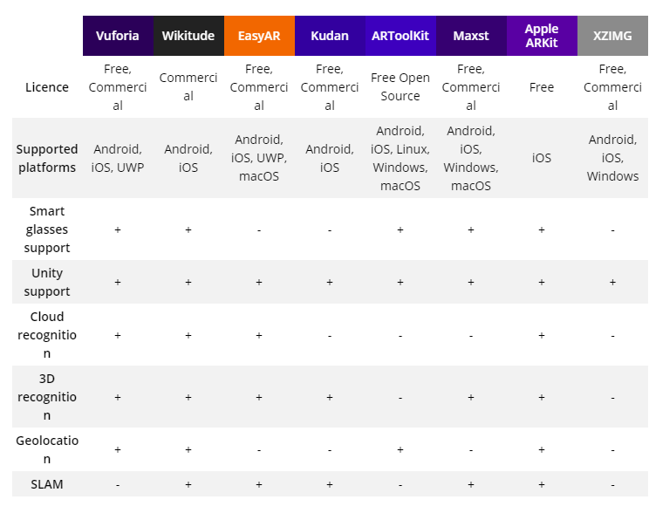

Figure 1 : comparison between Vuforia And another's SDK

# 2.2 DIGITAL VS PRINTED MENU FOR RESTAURANTS

* **PRINTED MENU**

As many of we know, most menus in restaurants don’t usually come with pictures, especially those menus which have many items. In the best case scenario, you probably are going to get a short description of the food that as being served. Usually when we go to the restaurant, even when there is a description, we ask the waiter to tell me what the most recommended dishes in the restaurant area. Paper menus need to be rotated throughout the day for different dining hours (lunch, dinner, happy hour, so on.).

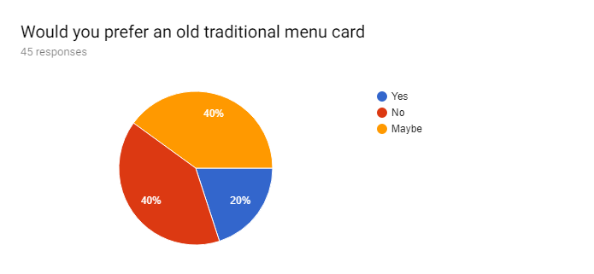

Figure 1 Survey of old digital menu

According to the study, we understand that most of the people are don't like printed menus because due to the clarification and concreteness.

Some people are often to go to them, and some not in this case customer is finding a new place for their satisfaction what the restaurant serves.

With the help of new AR Technology, we can help to evaluate their food ordering, and it will contribute to the customer for ordering the food.

The restaurant needs to new innovative promotions and marketing and business strategy to increase their customer.

* **DIGITAL MENU**

With a digital menu, high-resolution and gorgeous 3D representation accompanies each menu item. Paper menus don’t offer streaming news feeds, embedded social media functions, customer feedback submission, and custom ordering specification submission fields, digital menus certainly do. In the survey, we conducted we found out that (percentage of people) would prefer the digital list.

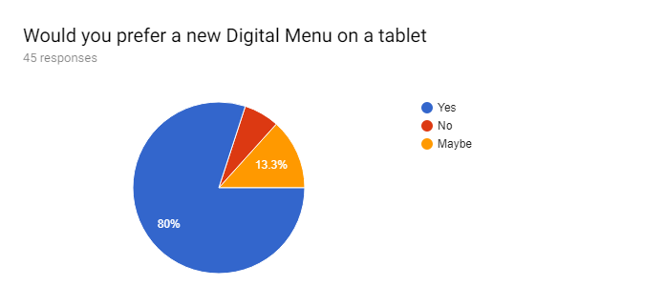

Figure 2 Digital Card Survey

According to the study, we understand that most of the people are like digital menus because due to the complete information and consistency.

Some people are like to prefer digital menus, and Digital menu is very eye-catching and sequential way to work with it

With the help of new AR Technology, The augmented food will help the customers to improve visibility, satisfaction and better improvement for the food they choose.

The food menu is a crucial marketing tool for any restaurant, from high-end excellent dining outfits to popular fast-food chains. Customers depend on lists to help them evaluate, compare and choose dishes. As a result, restaurants rely heavily on reviews, word of mouth and in-house staff to supplement food menus, attract customers and sell plates.

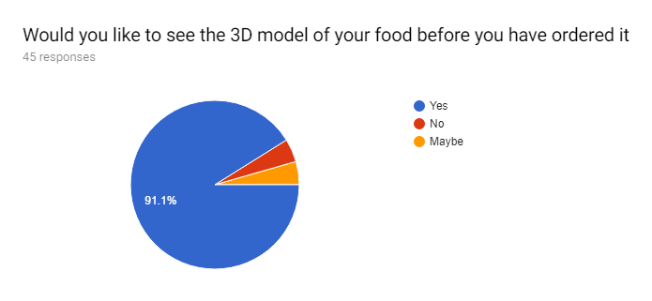

Figure 3 Digital Menu Card Survey

Both diagrammatic representations we can understand the audience needs innovative in their day to day activity, and it shows they are environmental adaptable to use the resource.

* **AR in restaurants**: The latest trend in restaurant marketing, augmented reality restaurant menus and food apps supplement existing lists with digital content designed to improve customer experience and drive sales.

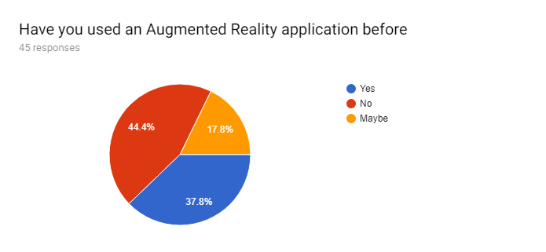

Figure 4 AR Survey

* The AR application can help in different sectors are as follows:-
  + **Improving visibility**: AR Food menus can be used to customized to show information about each food items, such as 3-D models, 360-degree visualizations, details of ingredients used, portion sizes, calorie and nutrition information.
  + **Upsell:** types of food items AR can help to implement the Visibility
  + **Promotions:** the Restaurant used for marketing purpose and provide too many benefits to the customers such as coupons, happy hours so on.
  + **Improve customer engagement**: As many of we know, most menus in restaurants don’t usually come with pictures, especially those menus which have many items.
  + **Gauge customer satisfaction**: the AR can help to serve the food as per customer, and it is the tool to create communication between AR application and user interactive. AR Application can help the customer.

**CHAPTER 3 : REQUIREMENTS AND ANALYSIS**

# 3.1 Problem Definition

As many of we know, most menus in restaurants don’t usually come with pictures, especially those menus which have many items. In the best case scenario, you probably are going to get a short description of the food that as being served. Usually when we go to the restaurant, even when there is a description, we ask the waiter to tell me what the most recommended dishes in the restaurant area.

What always frustrated us, is that if there were a picture, it would have made the decision so much easier. What we usually do, and we know it’s not polite, is getting a sneak pick to see what other people around me are eating, maybe it will help my decision easier.

The bottom line is that with pictures it is so much easier to make a decision.

Many people do not understand the menu, and they need to get the information: what are the ingredients, how is it cooked, is it spicy or not, nutritional information, the image of the item, etc.

When ordering the different food kinds of questions comes in mind about regarding food choice.

The project is on marker-based detection which you scan or detect QR code or Image. After examining the objects, it will display output.

# 3.2 Requirement Specification

With this in mind, it feels like the right time to look again at how augmented reality (AR) – now approaching the ‘Slope of enlightenment’ – might make an impact across different sectors, starting with the restaurant sector and augmented interactive restaurant menus.

During the early buzz around AR, restaurant chains were quick to pick up on the idea of bringing their menus to life with additional layers of digital content. The ability for consumers to view nutritional information or use AR to entertain children during waiting times were solid use cases although they were often implemented as ‘test and learn’ projects (including interactive restaurant menus) rather than longer-term strategic activity.

Of course, we believe that the goal is to take this idea and to make it available for many more restaurants, preferably get a global reach.

The digital I pad is necessary for the AR content on the table. If you use it without a marker and enter a code or something, you might not be able to do it on the table due to the surface not being easily scanned able by the app.

# 3.3 Planning and Scheduling

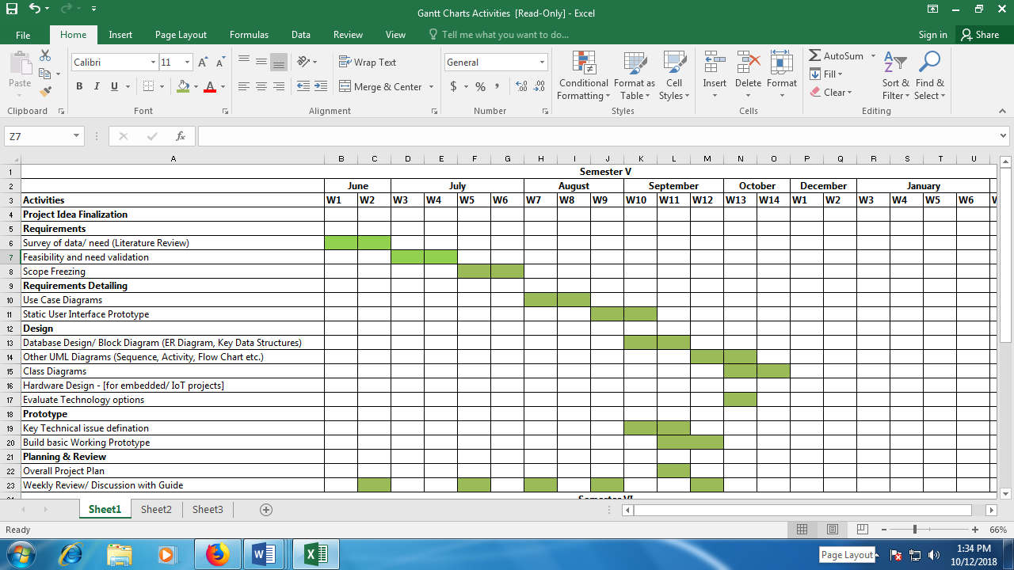

Figure 5 3.3 Gantt Chart

In this project, we are using the waterfall model because it helps to implement each phase of system requirements.

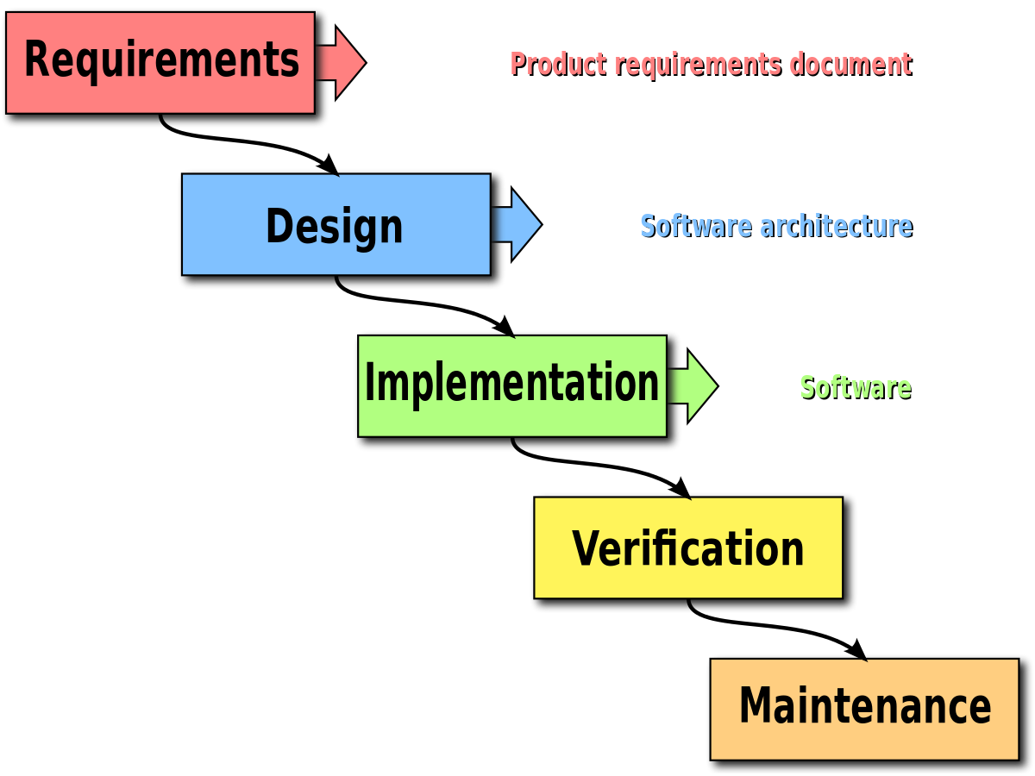

Figure 6 3.3.1 WaterFall Models

**1.Requirements**

In this phase, user requirement is necessary to know about developed.

Activity Stream:

A user wants to view the latest application via mobile dashboards so they can get a better understanding of what is in place.

API ,A developer wants to integrate with the mobile Device so they can consolidate with Activity Stream. DataBase requirements connection between the application and the server.

Customs evaluation of the application.

In these, we required to need of customer resource we need to make a custom wlogin page to check whether it is connected to the admin server after successful hence we proceed forward.

**2.Design**

The restaurant would decide the user interface of the application as they might require it to be in a specific theme. For fundamental demonstration purpose, we have created a UI as per customer point of view, and It will be varying from restaurant to restaurants.

The 3d models that will be used will be the representation of the food so we will be using images to reconstruct a 3d model for this application.

**3.Implementation**

This phase is essential for further iteration phase, and it will help to forward another execution of the application. We provide the application which main features like Admin and another login page after a succession of it. Further steps list of food menus and their information this part is easy but another part, i.e. to add 3D model is quite complicated because it depends object-oriented and it required platform independent.

Implementation parts such as 3D model, view information, feedbacks review, payment method are the main phases of the implementation.

# 3.4 Software and Requirement

### 3.4.1. PLATFORMS

The Augmented reality food menu has been created for a multiple of platforms including iOS, Android, Windows Phone and also web browsers and can be useful from mobiles & tablets.

### 3.4.2 UNITY

The Unity is a cross-platform game engine developed by Unity Technologies. It is used to create both three-dimensional and two-dimensional games as well as simulations for its many platforms.

The Unity used for buildings games, animation, images recognized so on it support multiple platforms for gaming and animations as well.There are multiple platforms as the following: iOS, Android, Tizen, Windows, Vuforia and so on. total 27 platforms used for unity games.

### 3.4.2 VUFORIA

The Vuforia SDK is implementation in gaming and augmentation of a virtual world in the form of 2D and 3D dimensional object target types including ‘markerless’ Image Targets, 3D Multi-Target configurations, and a way of addressable Fiducially Marker, known as a Vumark. Vuforia provides Application Programming Interfaces (API) in C++, Java, Objective-C++ (a language utilizing a combination of C++ and Objective-C syntax), and the .NET languages through an extension to the Unity game engine. In this way, the SDK supports both native development for iOS and Android while it also enables the development of AR applications in Unity that are easily portable to both platforms.



Figure 7 Unity and Vuforia

### 3.4.3 VISUAL STUDIO

Microsoft Visual Studio is an integrated development environment(IDE) from Microsoft. The primary used for visual studio is to develop computer programs, as well as websites, web apps, web services and mobile apps.

It is a general-purpose, multi-paradigm programming language encompassing strong typing, imperative, declarative, functional, generic, object-oriented (class-based), and component-oriented programming disciplines

.NET language is an extension to the Unity game engine. In this way, the SDK supports both native development for iOS and Android while it also enables the development of AR applications in Unity that are easily portable to both platforms.

AR applications developed using Vuforia are therefore compatible with a broad range of mobile devices and tablets.



Figure 8 Visual Studio

### 3.4.4 AUTODESK CAP

Fusion 360 is the first 3D CAD. It helps to connect the entire product development process in respected IDE for both Mac and PC. Design, test, and fabricate in a single tool. Work anywhere.

# 3.5 Preliminary Product Description

The AR food menu is a crucial marketing tool for any restaurant, from high-end excellent dining outfits to popular fast-food chains. Customers depend on lists to help them evaluate, compare and choose dishes. Space considerations prevent restaurants from adding too much information or too many pictures to their menus. As a result, restaurants rely heavily on reviews, word of mouth and in-house staff to supplement food menus, attract customers and sell dishes.

Augmented Reality (AR) is one of the upcoming thread trends in restaurant marketing, and we’re seeing inspiring examples of its application popping up all over the world. It helps to the improved paper-based menu system. Diners coming to the restaurants can have the interactive dining experience with the help of AR app.

This cloud helps us to develop and implement unique marketing executions and elevate your business to reach new possibilities.

We understand the product which they include features like feedback and indigents view innovative technology like augmented reality. It could predict to succeed by increasing the customer base of the industry. The restaurants can benefit.

What can be the content of this Augmented Menu? Let me give some small ideas, ingredients of Menu:

1. Each item with all its parts

2. The introduction of the food Dishes

3. The reviews are written or read by people (these can be audio, video and photo reviews)

4. Advice and tips for vegetarians and meat-lovers. (Feedback)

5. Advice and information about calories.

**CHAPTER 4 SYSTEM DESIGNS**

# 4.1 Basic Modules

The mechanism of the applications is user-friendly to use. The Application Augmented Reality is used for multiple different devices like Android Smartphones, IOS Device, Tablets and I-pad.

The methodology is very accurate and sequential process. When we want to order the food but in case you not sure whether it is efficient to eat or not then in the application there is a list of Features are following as:

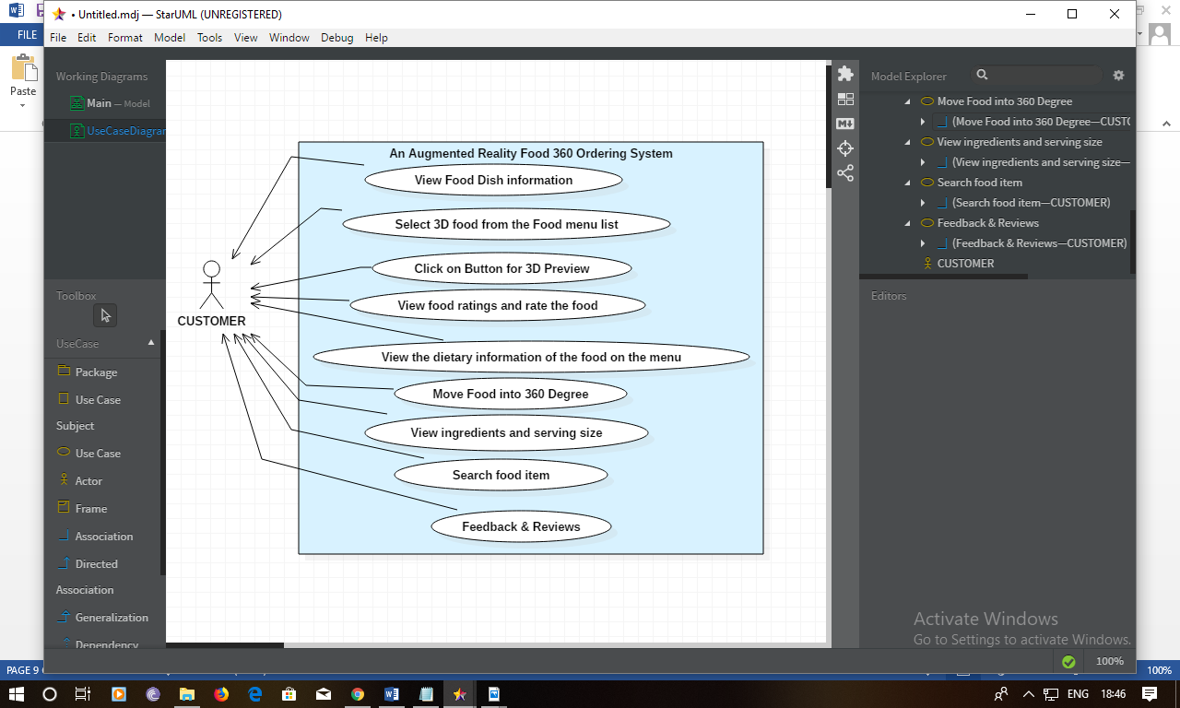

Figure 9 4.1 Use Case diagram for food 360 Ordering System

# 4.2 Data Design

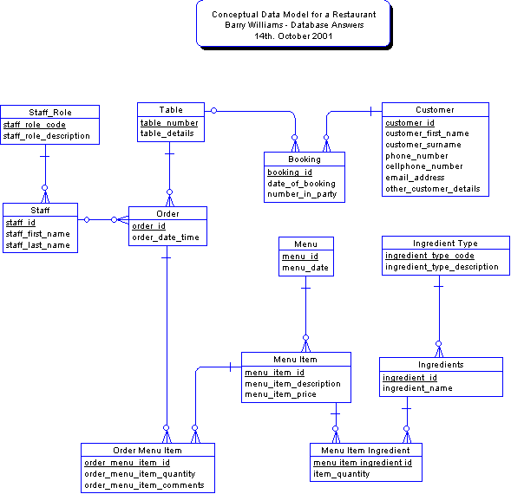

Figure 10 4.2 DataBase Design of Application

### 4.2.1 Schema Design

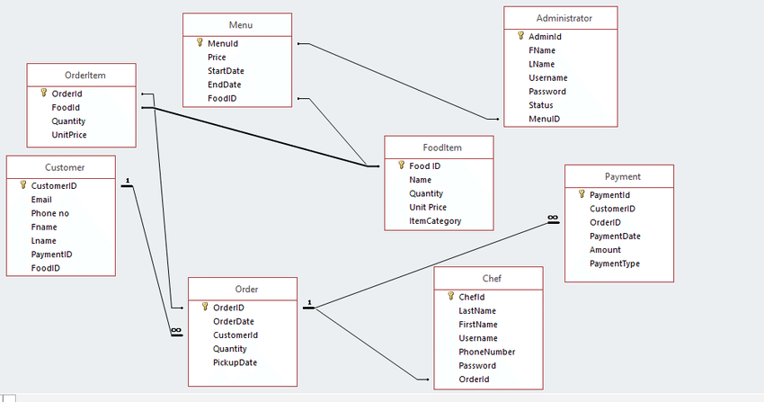

Figure 11 4.2.1 Schema Design

### 4.2.2 Data Integrity & Constraints

* + - * Category Details

|  |  |  |  |  |
| --- | --- | --- | --- | --- |
| Column Name | Data Type | Size | Description | Constriant |
| Category _ Id | Numeric | (2,0) | Id of the category. | Primary key |
| Category _Description | Varchar | (20) | Foods of Category | Not Null |
|  |  |  |  |  |

* + - * FoodItems**_Details**

|  |  |  |  |  |
| --- | --- | --- | --- | --- |
| Column Name | Data Type | Size | Description | Constriant |
| FoodItem_ID | Numeric | (5,0) | Id of the FoodItem | Primary Key |
| FoodItem_Name | Varchar | (30) | Name of FoodItem | Not null |
| Category_Id | Numeric | (5,0) | The id of the Category | Not Null |
| Rate | Numeric | (2) | Rate of Item | Not Null |

* + - * Item**_Master**

|  |  |  |  |  |
| --- | --- | --- | --- | --- |
| Column Name | Data Type | Size | Description | Constriant |
| Item_Id | Numeric | (3,0) | Id of the Item. | Primary |
| Item_Name | Varchar | (20) | One food item contains many items | Not Null |

* Table**_Master**

|  |  |  |  |  |
| --- | --- | --- | --- | --- |
| Column Name | Data Type | Size | Description | Constriant |
| Table_Id | numeric | (2,0) | The id of the Table Master | Primary key |
| TableCapacity | Varchar | (30) | The capacity of the customer in one table | Not Null |
| Emp_Id | Numeric | (2,0) | The id of the Employee | Foreign Key |

* Customer**_**information.

|  |  |  |  |  |
| --- | --- | --- | --- | --- |
| Column Name | Data Type | Size | Description | Constriant |
| Customer_Id | Numeric | (5,0) | The id of the customer | Primary key |
| Name | Varchar | (20) | CustomerName | Not null |
| mobile_no | Varchar | (10) | Mobile no of cust | Not Null |
| Email | Varchar | (20) | Cust email id | Not null |
|  |  |  |  |  |

* Order **_**Details

|  |  |  |  |  |
| --- | --- | --- | --- | --- |
| Column Name | Data Type | Size | Description | Constriant |
| Order_Id | Numeric | (5,0) | The id of the order | Primary key |
| Orderdate | Datetime | - | Date of the order | Not Null |
| Table_Id | Numeric | (5,0) | The id of the master table | Foreign key |
|  |  |  |  |  |

* Order **_**Items

|  |  |  |  |  |
| --- | --- | --- | --- | --- |
| Column Name | Data Type | Size | Description | Constriant |
| OrderItem_Id | Numeric | (5,0) | The id of the order items | Primary key |
| Order_id | Numeric | (5,0) | The id of the orders | Foreign key |
| FoodItem_id | Numeric | (3,0) | The id of the food items | Foreign key |
| Quantity | Numeric | (3,0) | The number of food items | Not Null |
| Rate_per_items | Numeric | 2 | Rate | Not null |
| Amount | Numeric | 5 | Amount | Not Null |

* sales **_**bills

|  |  |  |  |  |
| --- | --- | --- | --- | --- |
| Column Name | Data Type | Size | Description | Constriant |
| salesbill_no | Numeric | (5,0) | The id of the sales bill | Primary key |
| Salesbilldate | Varchar | 15 | Date of the sales bill | Not Null |
| order_id | numeric | (5,0) | Id of the order | Foreign key |
| Customer_id | numeric | (5,0) | The id of the cust | Foreign key |
| Amount | numeric | 5 | Amount | Not Null |
| Tax | numeric | 3 | tax | Not null |
| Net Amount | numeric | 5 | Net amount | Not Null |

* bill**_fooditems**

|  |  |  |  |  |
| --- | --- | --- | --- | --- |
| Column Name | Data Type | Size | Description | Constriant |
| Bilitems_id | Numeric | (5,0) | The id of the bill item | Primary key |
| salesbill_no | numeric | (5,0) | Id of sales bill | Foreign key |
| FoodItem_id | Numeric | (5,0) | Id of fooditem | Foreign key |
| Quantity | Numeric | (3,0) | The quantity of the bill items | Not Null |
| Rate_per_items | Numeric | 2 | rate | Not null |
| Amount | Numeric | 5 | Amount | Not null |

* Payment **_ collection**

|  |  |  |  |  |  |  |  |  |
| --- | --- | --- | --- | --- | --- | --- | --- | --- |
| Column Name | | Data Type | | Size | | Description | | Constriant |
| Payment_id | Numeric | | (5,0) | | Id of payment | | Primary key | |
| order_id | Numeric | | (5,0) | | Id of order | | Foreign key | |
| Customer_id | Numeric | | (5,0) | | Id of customer | | Foreign key | |
| Paid_Amount | Numeric | | 6 | | amount | | Not Null | |
| Paid_mode | varchar | | 10 | | cash | | Not null | |
|  |  | |  | |  | |  | |

* FoodItem**_Item**

|  |  |  |  |  |
| --- | --- | --- | --- | --- |
| Column Name | Data Type | Size | Description | Constriant |
| foodItem_id | numeric | (5,0) | Id of the fooditem | Composite key |
| Item_id | numeric | (5,0) | The id of the item | Composite key |

### 4.3.1 ER Diagram

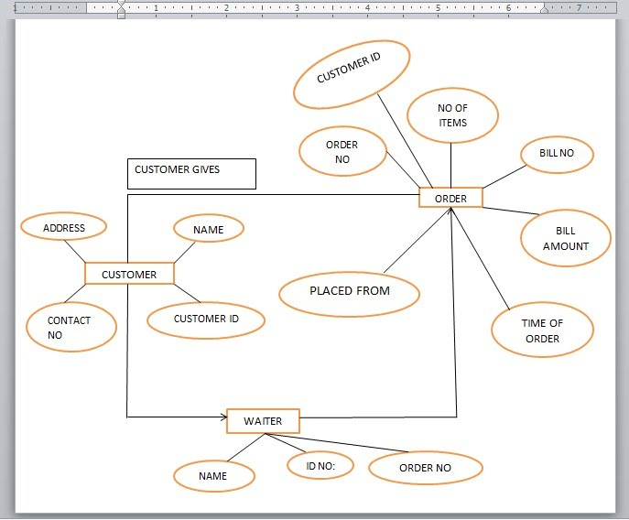

Figure 12 4.3.1 ER Diagram

### 4.3.2 Class diagram for Food Order and Bill

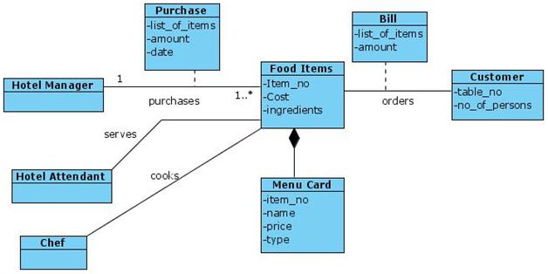

Figure 13 4.3.2 Class diagram for Food Order and Bill

### 4.3.3 Use Case Diagram



Figure 14 4.3.3 Use Case Diagram

### 4.3.3.1 Use Case Diagram

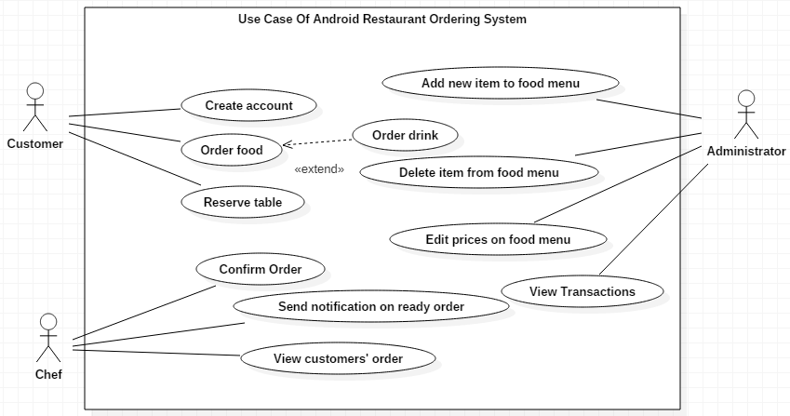

Figure 15 4.3.3.1 Use Case of Restaurant Ordering System

### 4.3.4 Sequence Diagram

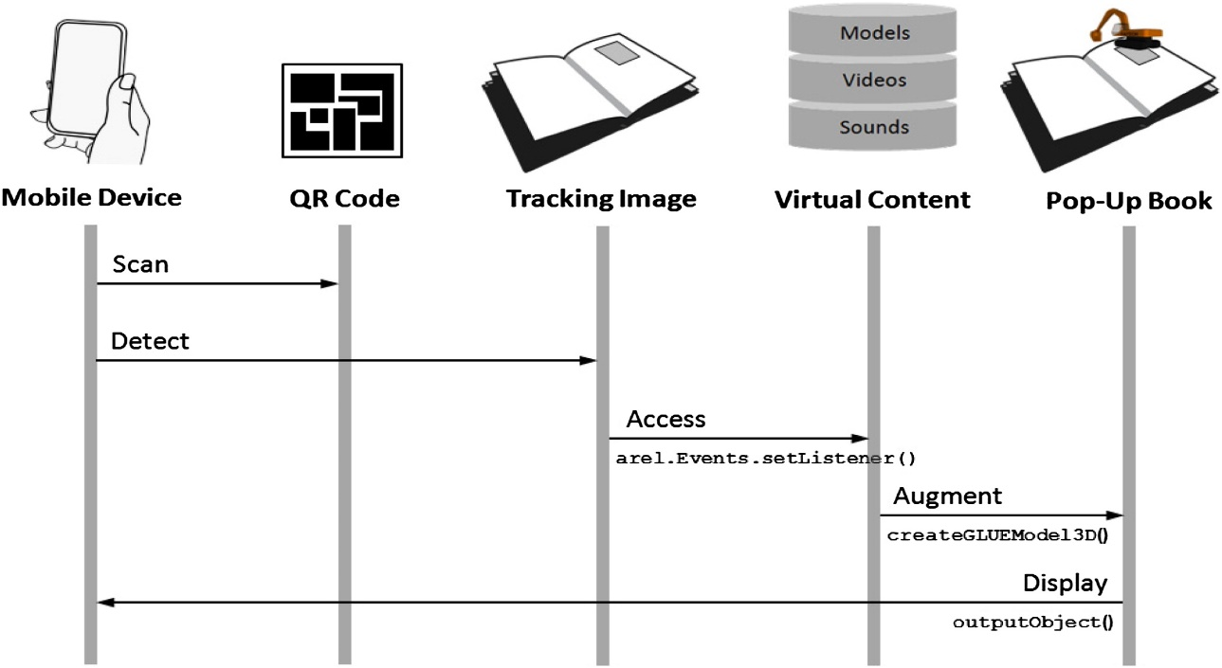

Figure 16 4.3.4 Sequence Diagram

### 4.3.5Activity Diagram of Food Order

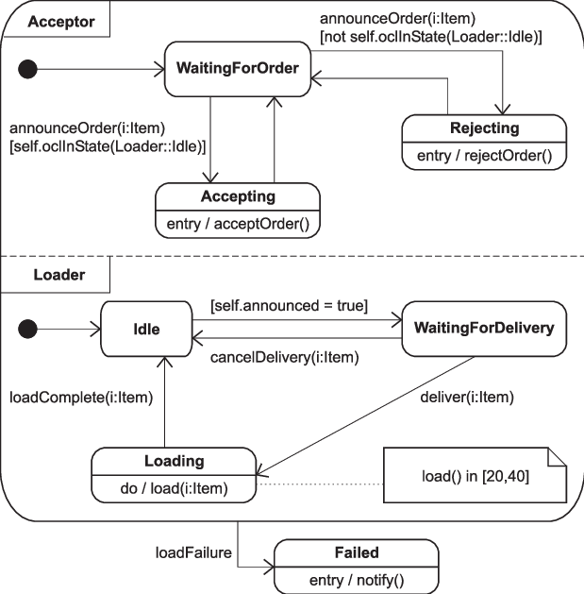

Figure 17 4.3.5 Activity Diagram of Food Order

### 4.3.6 Deployment Diagram of Augmented Application

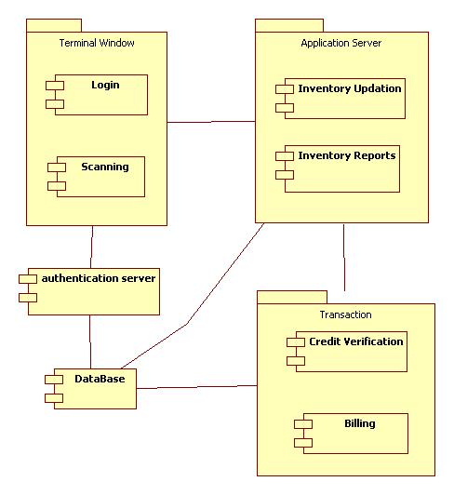

Figure 18 4.3.6 Deployment Diagram of Augmented Application

### 4.3.7 Menu Tree

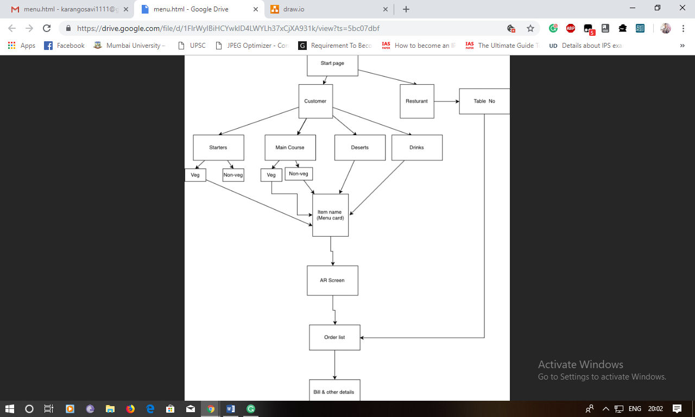

Figure 19 4.3.7 overview process Application Menu Tree

### 4.3.8 Event Table

|  |  |  |  |  |  |  |
| --- | --- | --- | --- | --- | --- | --- |
| **No.** | **Events** | **Trigger** | **Source** | **Activity** | **Response** | **Destination** |
| 1. | Customer | Selection | user | Make a selection from the main menu | Data Server |  |
| 2 | Collect | Information from user | Application | To select from the food list | Food Selected |  |
| 3. | Data Server collects information | proceed | Info Received | View information | The receiver is to be informed |  |
| 4. | Customer Received  bill | New Transaction | Customer Received | Create a New Transaction | Transaction confirmed | Food order placed |
| 5 | feedback | Get feedback |  | Giving feedback | reviews | Submitted |

Figure 20 4.3.8 Event Table

### 4.3.10 Security Issues

Nowadays Augmented reality is going activity stream. In the most simplistic terms, Augmented Reality is known as to add something to improve or complete it.

In virtual reality, The risks are much higher compared to Augmented reality because there is no coordination between the physical world and the artificial world. In the case of augmented reality, the only part to create Artificial world components and combined into are all physical.

* **AR’s components to security risks can be the following factors:**
* Unreliable content - AR Application are merely facilitated the augmentation process, but the content is created and delivered by third-party groups and applications.
* AR lacks a scalability standard.
* Augmented Reality apps cannot support the invalid authorizations.

### 4.3.11 Test Cases Design

|  |  |  |  |
| --- | --- | --- | --- |
| Inspection Check | Pre-Condition | Test Data | Priority |
| Login Modules | Customer should select on customer button. so that it will show food menu list | Should Succeed in Food Menu | Medium |
| Customer Modules | The Customer should order from food menu so it can display price & different categories with respect selection mode | If customer select drinks it should be display types of drinks with respect to menu. | High |
| Selection Modules | Different categories with respect selection mode | Selection List | High |
| AR View | If customer selects the food and it should be display 3D models | 3D Models pop up in real view | High |

### 

### 4.3.9 User Interface Design

* 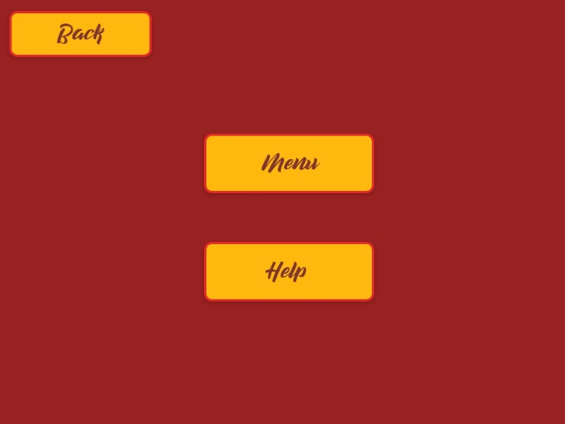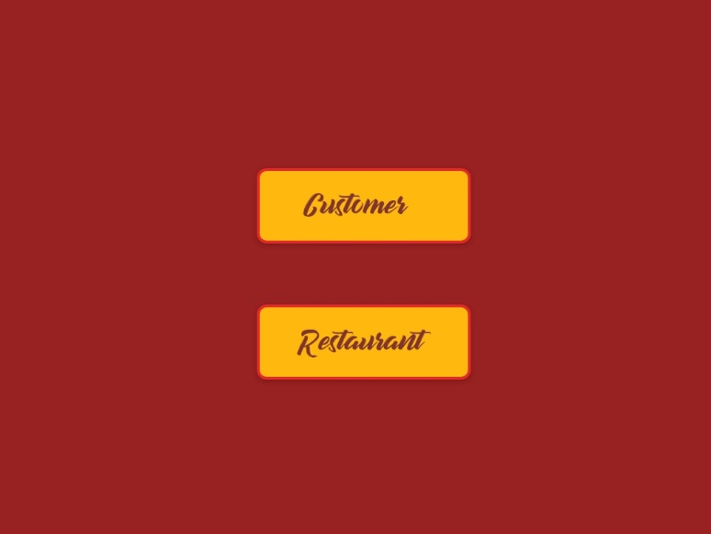**Login Modules**

Figure 21 Login Modules UI

* **Selection Modules**

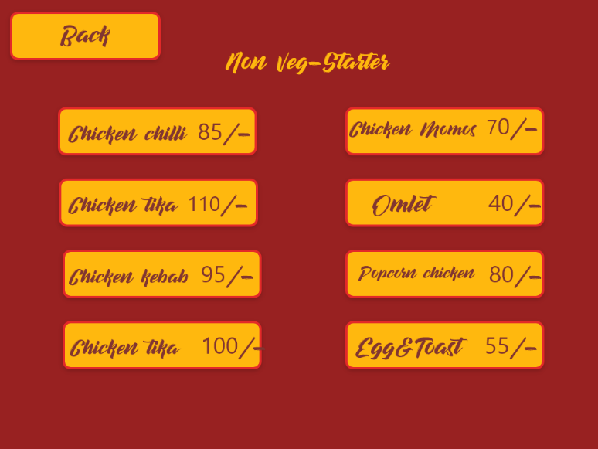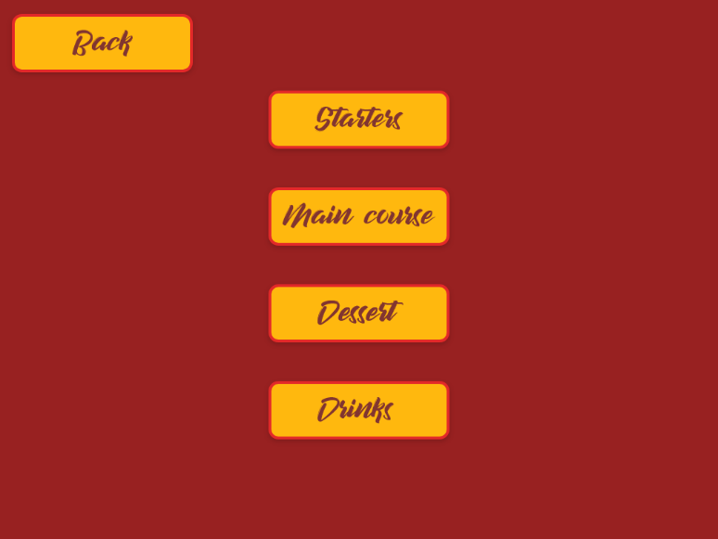

Figure 22 Selection Modules UI

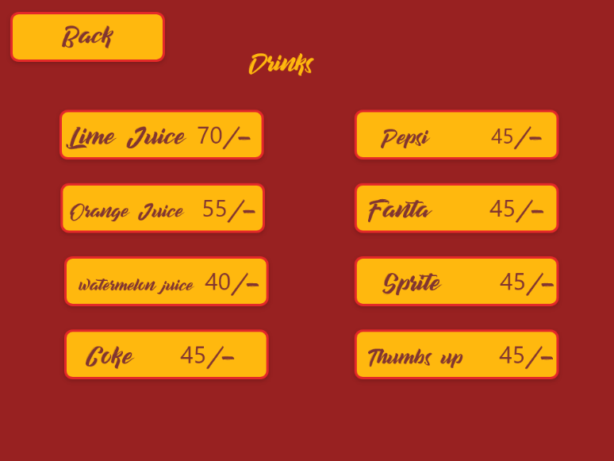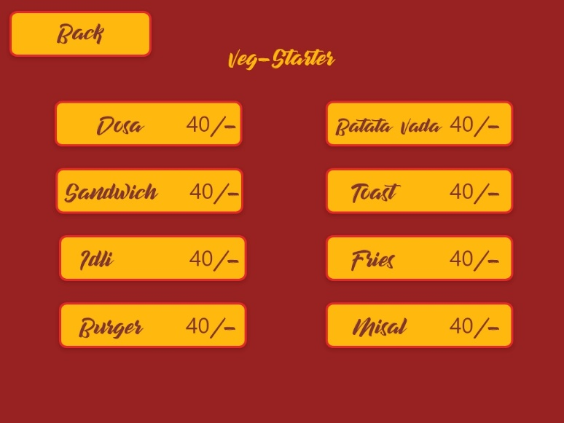

* **Table and order modules**

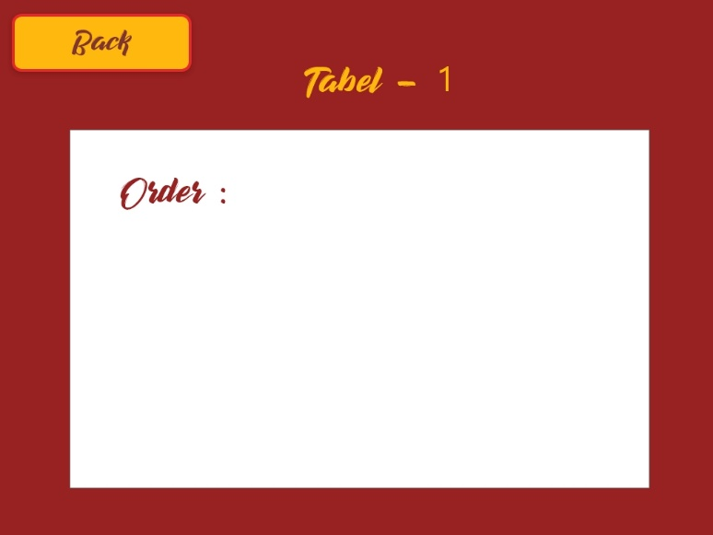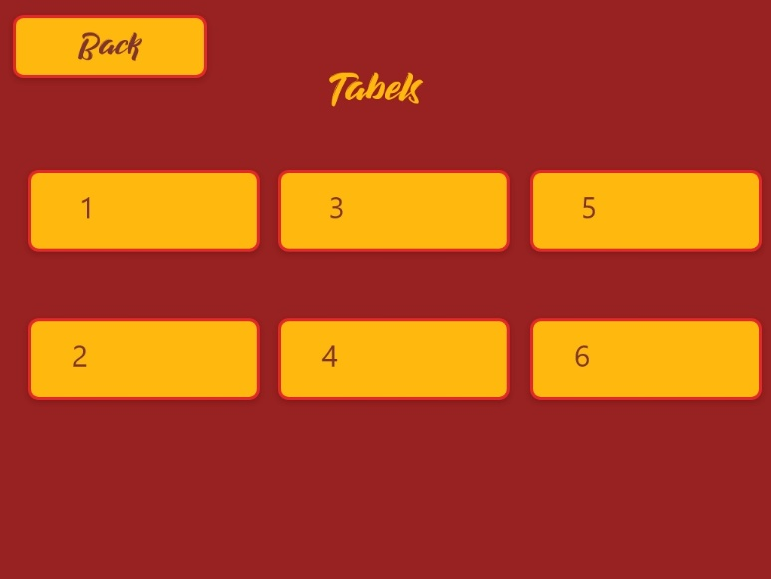

Figure 23 Table and order modules UI

* **Feed Back, View Info and Ordered placed modules.**

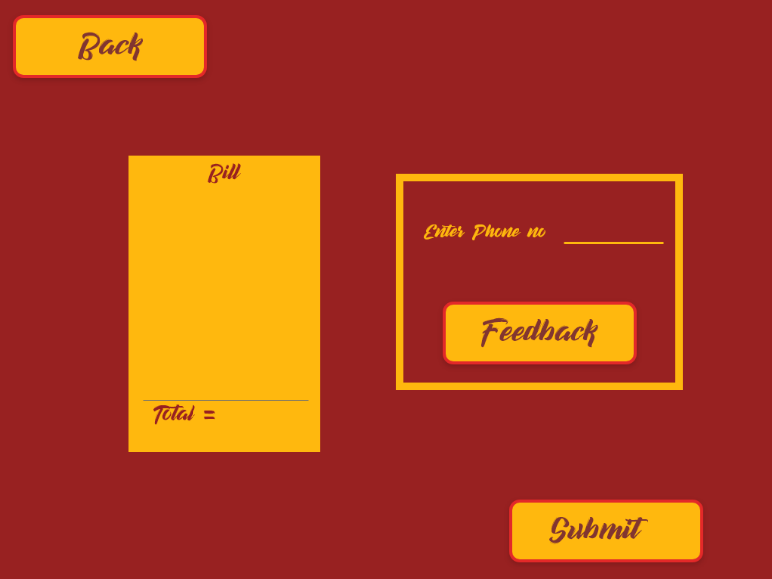

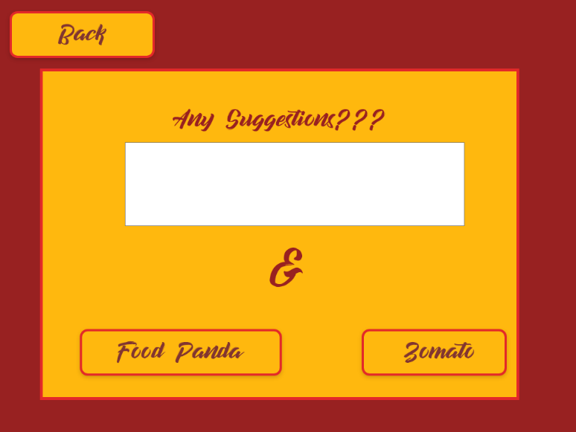

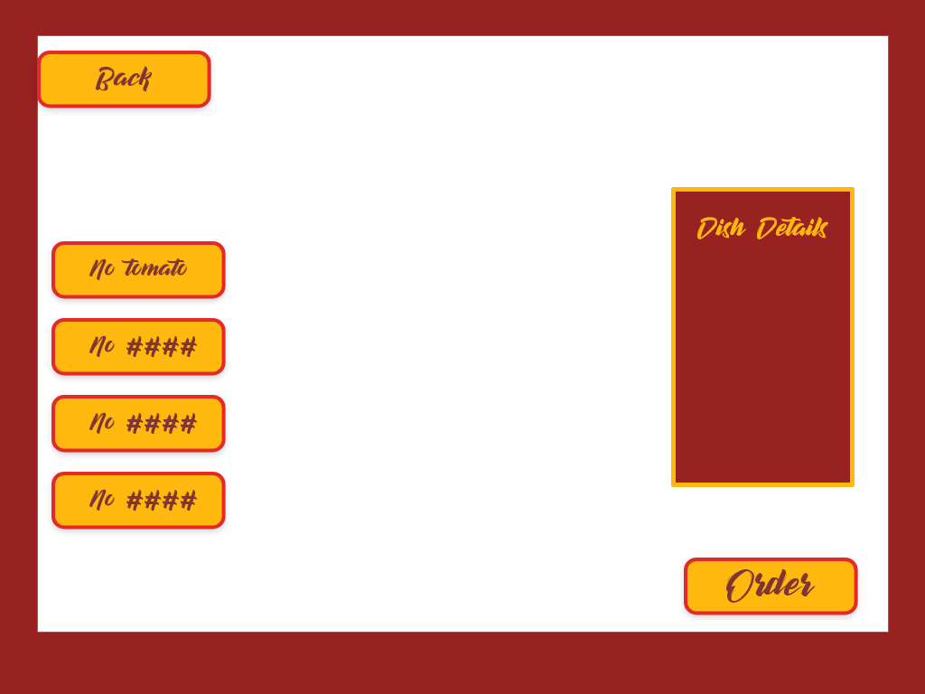

Figure 24 Feed Back, View Info and Ordered placed modules UI

# References & Bibliography

1. Jianqiang Sun, Lei Xie, QingliangCai, Chuyu Wang, Jie Wu, and Sanglu Lu,“RF-ISee : Identify and Distinguish Multiple RFID Tagged Objects in Augmented Reality Systems”, 2016 IEEE 36th International Conference on Distributed Computing Systems, pp.723,724.
2. H Karimi and A.Hammad (eds.) ,“Telegeoinformatics: Location-based Computing and Services”.,Taylor& Francis Books Ltd., 01/2004 9 Chapter Nine Mobile Augmented Reality Tobias H. Höllerer Steven K. Feiner
3. “The future directions of mobile augmented reality applications”, Study Tour Pixel 2010 ,University of Twente
4. Barnum, P. et al. “Dynamic seethroughs: Synthesizing hidden views of moving objects. In Mixedand Augmented Reality”, 2009. ISMAR 2009. 8th IEEE International Symposium on, pages 111-114. 2009.

1. Caudell, T. and Mizell, D. “Augmented reality: An application of heads-up display technologyto manual manufacturing processes”,In roceedings of the Hawaii International Conferenceon System Sciences, volume 25, pages 659-659. IEEE INSTITUTE OF ELECTRICAL NDELECTRONICS, 1992.
2. Chen, D. et al. “Streaming mobile augmented reality on mobile phones”, In Proceedings of the 2009, 8th IEEE International Symposium on Mixed and Augmented Reality, pages 181-182. Citeseer,2009.
3. Gunnarsson, A. et al. “Visualization of sensor data using mobile phone augmented reality”, In Proceedings of the 2006 Fifth IEEE and ACM International Symposium on Mixed and AugmentedReality (ISMAR'06)-Volume 00, pages 233-234. IEEE Computer Society, 2006.
4. Hong, Y. et al. “Mobile pointing and input system using active marker”, In IEEE/ACM InternationalSymposium on Mixed and Augmented Reality, 2006. ISMAR 2006, pages 237-238. 2006.
5. Milgram, Paul, T.H.U.A.K.F. “Augmented reality: a class of displays on the reality-virtuality”,continuum. volume 2351, pages 282-292. 1995.
6. Papagiannakis, G., Singh, G. and Magnenat-Thalmann, N. “A survey of mobile and wirelesstechnologies for augmented reality systems”, Computer Animation and Virtual Worlds, 19(1):3,2008.
7. Seichter, H. et al. “Multitouch interaction for Tangible User Interfaces”, In Mixed and AugmentedReality, 2009. ISMAR 2009. 8th IEEE International Symposium on, pages 213-214. 2009.
8. Thomas, B. “Evaluation of three input techniques for selection and annotation of physical objectsthrough an augmented reality view”, pages 3336. 2007.
9. Wagner, D., Schmalstieg, D. and Bischof, H. “Multiple target detection and tracking with guaranteedframerates on mobile phones”, ISMAR09, 2009.
10. Kunal Raut, Priyanka Khare, Aishwarya Kamble,Sachin Deshpande AR in Restaurant Copyright to IJIRCCE DOI: 10.15680/IJIRCCE.2018.0602099

# Website Used

* <https://www.juegostudio.com/ar-based-food-menu-case-study>

(TO Study About AR Based Food Menu Case Study With Respect to Future enhanced in Restaurants)

* <https://www.augmented-reality-games.com/imact.php>

(To study about survey with respect to daily problems and day to day use of AR)

* <https://insights.samsung.com/2016/09/12/augmented-reality-technology-helps-hotels-stand-out/>

(To study about AR Solutions help to respected daily problems to solve customer enhance and experiences for Hotels & Restaurants)

* <https://docs.unity3d.com/Manual/index.html>

(Unity Documentation)

* <https://developer.vuforia.com/>

(Vuforia Development )

# Summary

Augmented Reality (AR) is known as to add something which is existing from the real world which helps to combined real-world object and virtual components in a real-world environment.

The AR food menus are a crucial marketing tool for any restaurant.

The current systems which are available in the market are not feasible for the Indian audience. It could be game-changing in the restaurant business as in India this has not yet been developed or deployed in some restaurants.

The primary goal of the project to create a system which user cannot tell the difference between real and virtual Augmentation of it.

Augmented reality Restaurant Menus and food Application Supplement existing menus with digital content designed to improve customer experience and drive sales. Customers depend on lists to help them evaluate, compare and choose dishes.

The AR food application helps in improvise visibility and improve customer engagement. It could be game-changing in the restaurant business as in India this has not yet been developed or deployed in some restaurants.

Restaurant marketing is getting more interesting and sophisticated, which means that to stand out from this flood of brands in people’s everyday life, we have to be creative, resourceful in order to attract consumers’ interest and make them relate to the product. Augmented reality advertising adds the life to the static Menu Cards. Well, this augmented reality Menu cards from distance looks normal, but when smartphones are projected before them, they become live.

Having an Augmented Reality App for restaurant helps you engage more customers, add more value and bring more revenue by transforming conventional traditional paper based menu system.